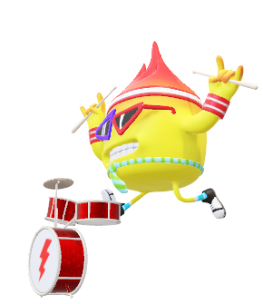**7th and 8th Grade Class Outline**

**Course Description:** This course is designed to involve the student in applying reading, writing, listening, speaking, and viewing skills in an independent manner through meaningful interdisciplinary tasks. Students will continue to develop an appreciation for literature through the study of literary elements in classic and contemporary selections. Emphasis is placed on moving from the literal to the abstract in the students’ critical thinking skills and in the use of language.

**Methods of Instruction:** Students will be engaged in the learning process by :

* Group lectures and discussions
* Hands-on activities such as projects
* Presentations
* Written compositions
* Individual exploration and research

**Course Competencies**

1. Use word recognition and vocabulary skills to communicate.

2. Apply strategies and skills to comprehend, respond to, interpret, or evaluate a variety

of texts of increasing levels of difficulty.

3. Express, communicate, evaluate, or exchange ideas effectively.

**Course Expectations:**

* Attendance is necessary to keep up with the class. If a student misses class time, they are missing the instruction time needed to learn a skill. However, if a student must miss class, they are required to make up missed work in a timely manner.
* Students are expected to arrive to class on time
* Students are required to participate in class and be respectful to their peers, themselves, and their teacher. Consequences for misconduct may include detention, written assignments, parent notification, or office referral.
* Each student is required to put forth their personal best. Everyone has something important and valuable to add to our learning experience. If a student is suspected of plagiarism or cheating, the parents and the principal will be notified and consequences will be determined.

**Grading:** Students will be graded in a variety of ways including formal assessments such as tests; participations grades for daily work; and authentic assessments using rubrics for presentations, projects, and written assignments.HW is posted on Castlelearning(Open CLEVER, Online)

We look forward to a great year!

Ms. Samuels [tsamuels@yonkerspublicschools.org](mailto:tsamuels@yonkerspublicschools.org)

SIGN UP FOR THE REMIND APP FOR CLASS NOTIFICATIONS. PLEASE SEE MY PAGE ON THE SCHOOL 5 WEBSITE. BELOW ARE EDUCATIONAL LINKS THAT WILL BE USED ALL YEAR:

 